INTERNSHIP REPORT

Internship Overview
As part of my professional training, I designed and implemented a Air Quality Index (AQI) Forecasting System that predicts air quality for the next three days with high accuracy. The system features a fully automated machine learning pipeline encompassing data collection, cleaning, feature engineering, model training, and CI/CD deployment. I leveraged Python, PostgreSQL, Feast, MLflow, and GitHub Actions for backend automation, and built an interactive, real-time web dashboard using Flask, HTML, and CSS to visualize AQI trends, forecasts, and analytics. This project allowed me to strengthen my expertise in data engineering, MLOps, and web development, while delivering a practical solution to a real-world environmental challenge.

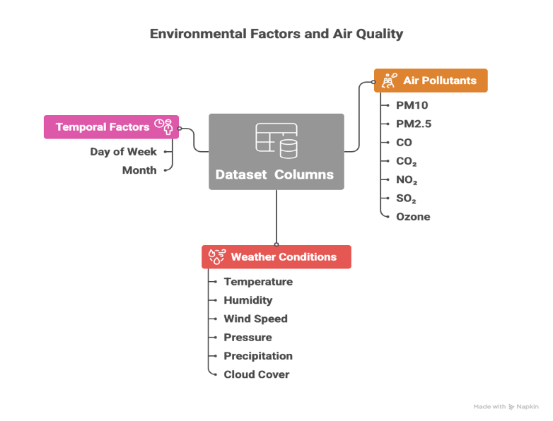
1.1. Feature Pipeline Development
During my internship, I designed and implemented a feature pipeline to prepare air quality data for modeling and forecasting. I collected three months of weather and AQI data from OpenWeather and Open-Meteo APIs, The data was preprocessed by handling missing values, removing duplicates, detecting outliers, ensuring feature consistency, and addressing skewness. AQI values were calculated using the Sub-Index / Breakpoint Method.
I performed feature engineering to enhance predictive power, including time based , rolling averages for PM2.5 and PM10, AQI change rates, and weather interaction features to capture temporal and pollution–weather patterns. The processed dataset was stored in CSV format and integrated with PostgreSQL and Feast, where PostgreSQL handled secure data storage and Feast managed feature consistency for both training and real-time prediction, ensuring an automated and reliable AQI pipeline.

1.2. Historical Data Backfill
Building on my initial three-month feature pipeline, I extended the process to a full-year Historical Data Backfill (1st Oct 2024 – 16th Oct 2025) to strengthen model training and evaluation. Using the same APIs (OpenWeather and Open-Meteo) and consistent feature set, I performed large-scale data collection, cleaning, and preprocessing following the standards established earlier. Through this phase, I applied the same data handling logic ensuring accuracy, consistency, and completeness across a much larger timeframe. I also created visual representations to analyze long-term air quality patterns and validate the data quality. This extensive effort was aimed at achieving the objectives to run feature pipelines for past dates and build a comprehensive dataset for model training and evaluation, demonstrating my ability to manage end-to-end data workflows with precision and persistence.

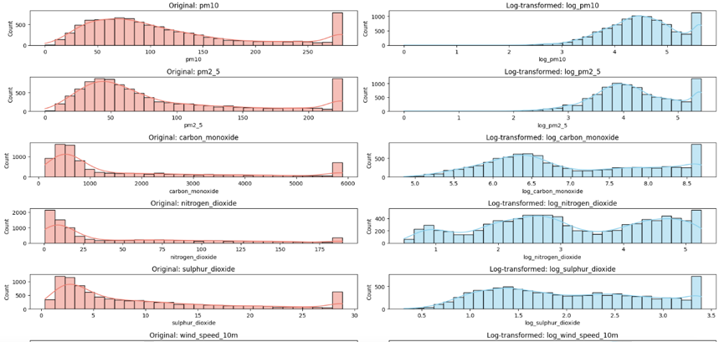
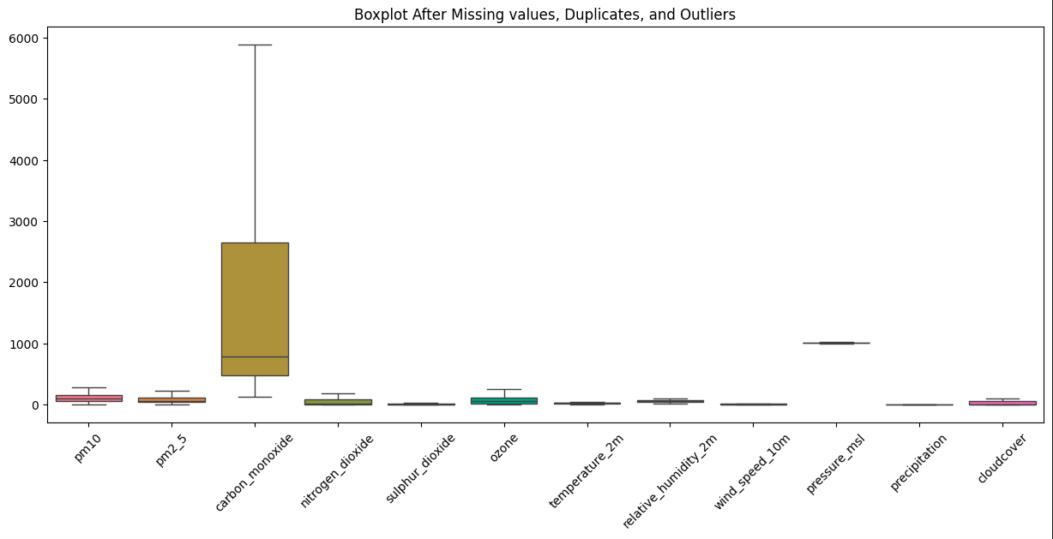

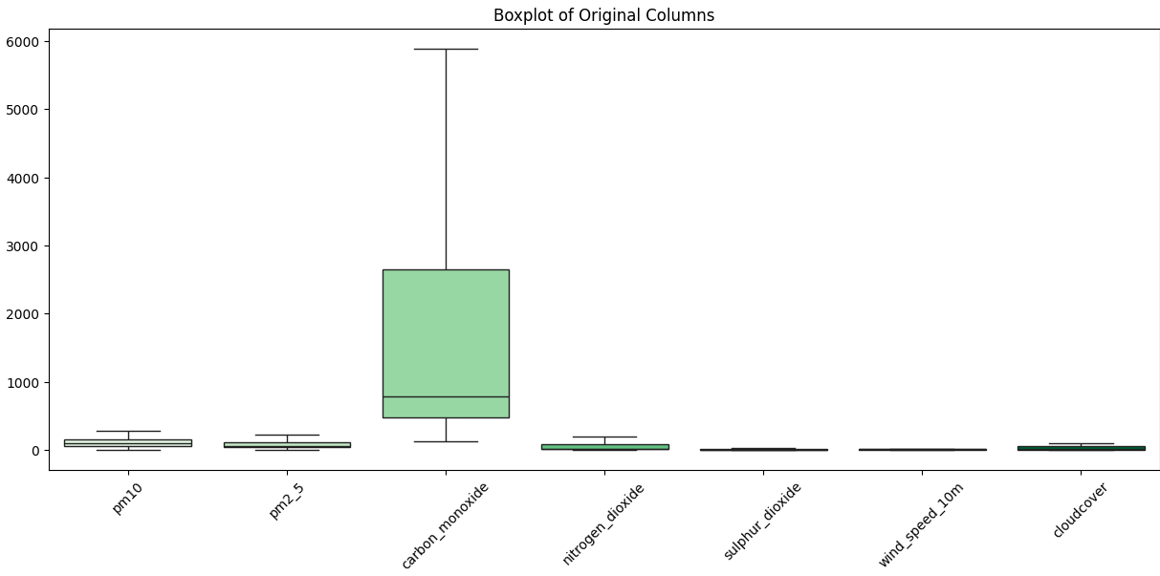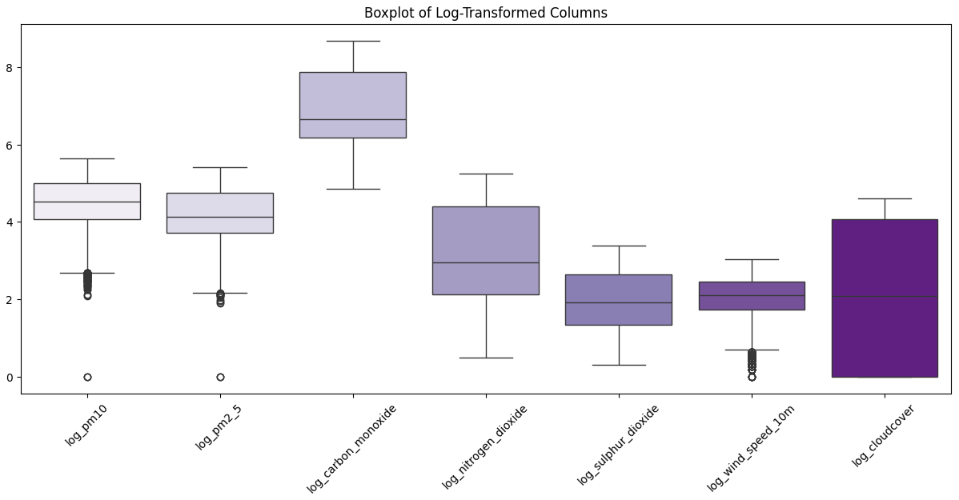

1.3. Training Pipeline Implementation
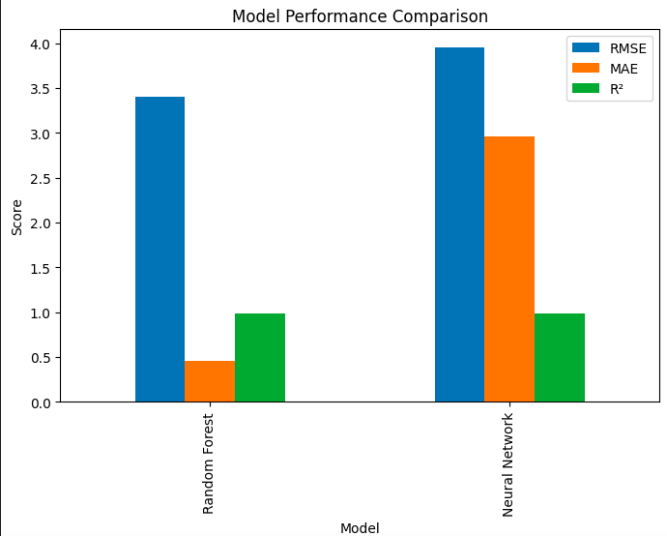
I developed a Training Pipeline to automate AQI model development. Historical features from Feast and targets from PostgreSQL were combined with weather, pollutant, and engineered features like rolling averages, AQI change rates, and weather interactions into a unified dataset for reproducible, large-scale training and testing.
I experimented with Linear Regression, Random Forest Regressor, and a Neural Network, with primary focus on the latter two. Models were trained and assessed using RMSE, MAE, and R² metrics. The Random Forest initially achieved an RMSE of 3.40, MAE of 0.45, and R² of 0.99, outperforming the Neural Network (RMSE 3.95, MAE 2.95, R² 0.98).
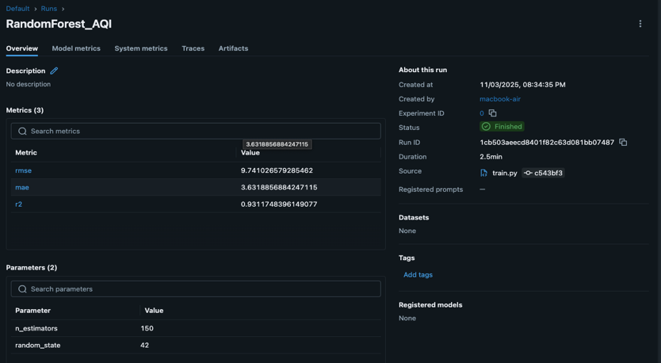
After incorporating additional data, the Random Forest maintained strong generalization with RMSE 9.74, MAE 3.63, and R² 0.93, confirming no overfitting.The Random Forest model was selected as the best-performing model due to its superior predictive accuracy and generalization ability. Since the performance metrics were calculated on test data, the high R² values accurately reflect strong model performance rather than overfitting, demonstrating that the model generalizes well to unseen data and performs reliably in real-world scenarios. The final model was saved using Joblib and registered in the Model Registry, ensuring deployment readiness and production reliability.
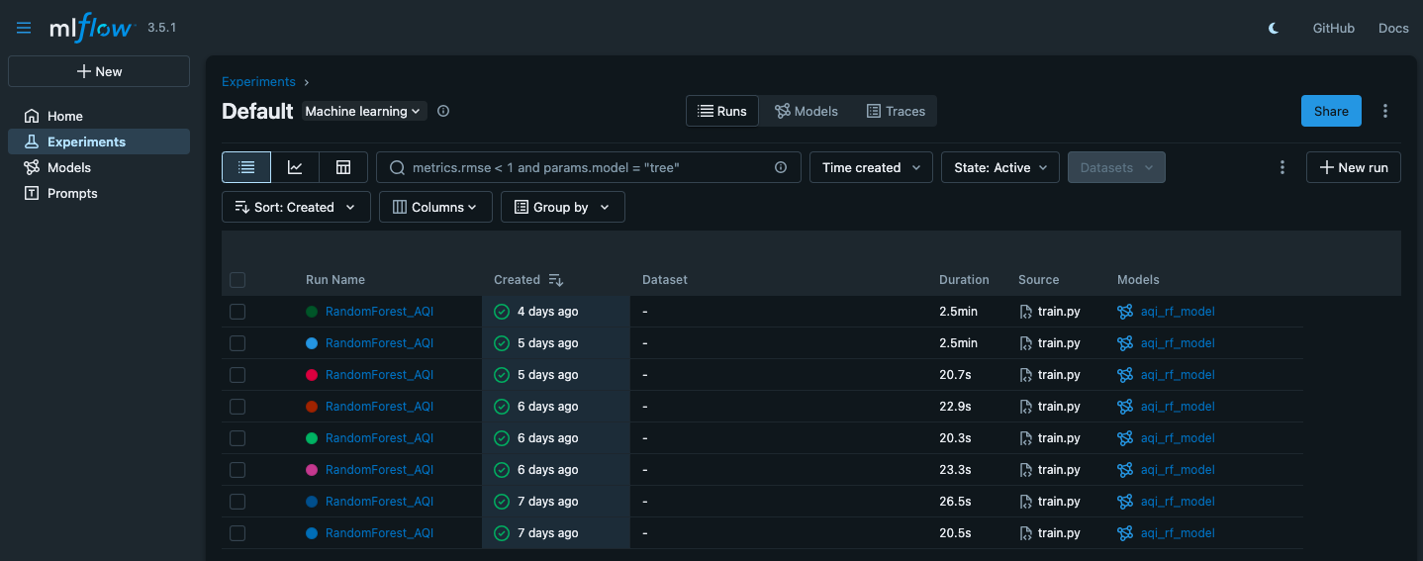
1.4. Automated CI/CD Pipeline
I implemented a fully automated CI/CD pipeline using GitHub Actions for the AQI forecasting system, covering data ingestion, feature engineering, and model training. The pipeline set up the environment, connected to PostgreSQL, launched MLflow for tracking, fetched and processed AQI and weather data (OpenWeather, Open-Meteo), stored features in PostgreSQL, and registered them in Feast. It then trained and evaluated models, saving the best-performing one for deployment. This pipeline shows how to automate data processing and model training, making the system easier to use and manage.
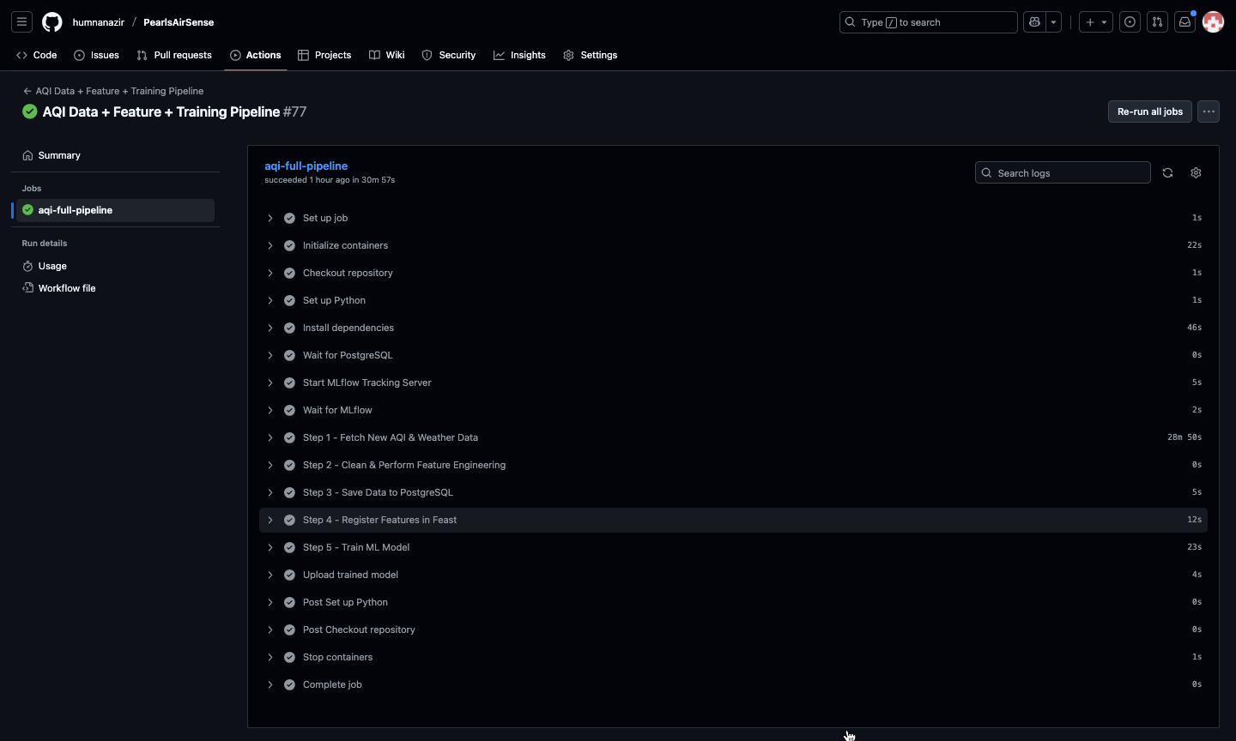

1.5. Interactive AQI Dashboard with Real-Time Forecasts & Analytics
The dashboard dynamically loads trained models and features from the Feature Store to generate real-time AQI forecasts for the next three days. It features a Live AQI Display showing the current air quality with a color-coded indicator, along with a Data Details Section presenting live readings of PM10, PM2.5, temperature, humidity, and wind speed. The AQI Trend Chart visualizes 24-hour air quality variations, while an Interactive Leaflet Map highlights nearby monitoring stations with color-coded markers. Additionally, 3-Day Forecast Cards display predicted AQI, PM2.5, and PM10 values using the Random Forest model. It also generates EDA visualizations of AQI trends and feature importance plots using SHAP, providing insights into key factors influencing air quality and enhancing model explainability.
